VLANS

Why should I take this module?

Welcome to VLANs!

Imagine that you are in charge of a very large conference. There are people from all over who share a common interest and some who also have special expertise. Imagine if each expert who wanted to present their information to a smaller audience had to do that in the same large room with all the other experts and their smaller audiences. Nobody would be able to hear anything. You would have to find separate rooms for all the experts and their smaller audiences.

The Virtual LAN (VLAN) does something similar in a network. VLANs are created at Layer 2 to reducing or eliminate broadcast traffic. VLANs are how you break up your network into smaller networks, so that the devices and people within a single VLAN are communicating with each other and not having to manage traffic from other networks. The network administrator can organize VLANs by location, who is using them, the type of device, or whatever category is needed. You know you want to learn how to do this, so don’t wait!

What will I learn to do in this module?

**Module Title: VLANs**

**Module Objective**: Implement VLANs and trunking in a switched network.

| Table caption | |
| --- | --- |
| **Topic Title** | **Topic Objective** |
| **Overview of VLANs** | Explain the purpose of VLANs in a switched network |
| **VLANs in a Multi-Switched Environment** | Explain how a switch forwards frames based on VLAN configuration in a multi-switch environment. |
| **VLAN Configuration** | Configure a switch port to be assigned to a VLAN based on requirements. |
| **VLAN Trunks** | Configure a trunk port on a LAN switch. |
| **Dynamic Trunking Protocol** | Configure Dynamic Trunking Protocol (DTP). |

**OVERVIEW OF VLANS**

## VLAN Definitions

Of course organizing your network into smaller networks is not as simple as separating screws and putting them into jars.

But it will make your network easier to manage. Virtual LANs (VLANs) provide segmentation and organizational flexibility in a switched network.

A group of devices within a VLAN communicate as if each device was attached to the same cable. VLANs are based on ***logical connections***, instead of physical connections.

As shown in the figure, VLANs in a switched network enable users in various departments (i.e., IT, HR, and Sales) to connect to the same network regardless of the physical switch being used or location in a campus LAN.

The figure shows a 3-floor building with a switch on each floor. The switches are connected to another switch which is connected to a router. Each floor has multiple hosts connected to it. There are three VLANs that span all three floors and contain multiple hosts on each floor. The VLANs are: VLAN 2, IT, 10.0.2.0/24; VLAN 3, HR, 10.0.3.0/24; VLAN 4, Sales, 10.0.4.0/24.

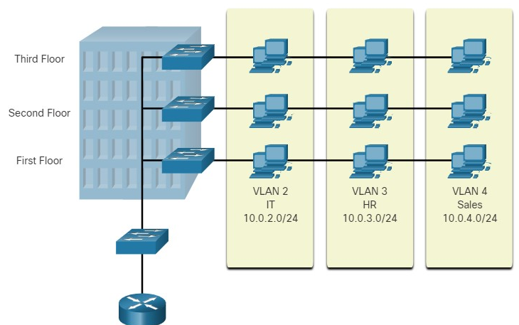

VLANs allow an administrator to segment networks based on factors such as function, team, or application, without regard for the physical location of the users or devices.

Each VLAN is considered a separate logical network. Devices within a VLAN act as if they are in their own independent network, even if they share a common infrastructure with other VLANs. Any switch port can belong to a VLAN.

Unicast, broadcast, and multicast packets are forwarded and flooded only to end devices within the VLAN where the packets are sourced. Packets destined for devices that do not belong to the VLAN must be forwarded through a device that supports routing.

Multiple IP subnets can exist on a switched network, without the use of multiple VLANs. However, the devices will be in the same Layer 2 broadcast domain. This means that any Layer 2 broadcasts, such as an ARP request, will be received by all devices on the switched network, even by those not intended to receive the broadcast.

A VLAN creates a logical broadcast domain that can span multiple physical LAN segments. VLANs improve network performance by separating large broadcast domains into smaller ones. If a device in one VLAN sends a broadcast Ethernet frame, all devices in the VLAN receive the frame, but devices in other VLANs do not.

Using VLANs, network administrators can implement access and security policies according to specific groupings of users. Each switch port can be assigned to only one VLAN (except for a port connected to an IP phone or to another switch).

3.1.2

Benefits of a VLAN Design

Each VLAN in a switched network corresponds to an IP network. Therefore, VLAN design must take into consideration the implementation of a hierarchical network-addressing scheme. Hierarchical network addressing means that IP network numbers are applied to network segments or VLANs in a way that takes the network as a whole into consideration. Blocks of contiguous network addresses are reserved for and configured on devices in a specific area of the network, as shown in the figure.

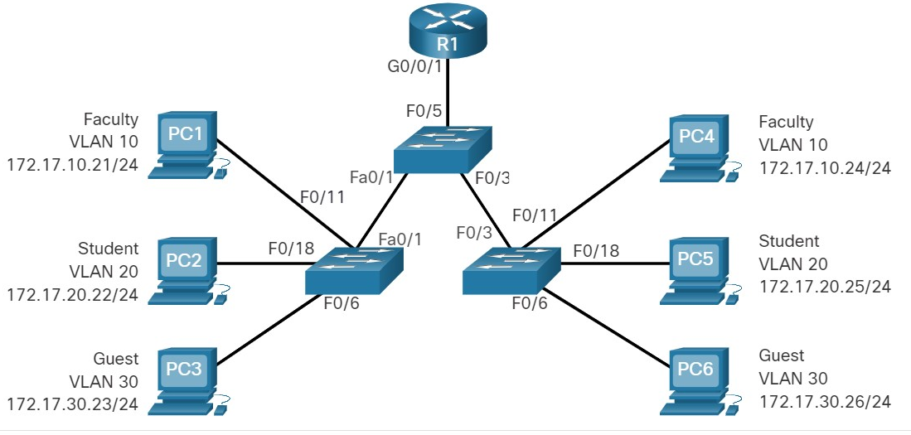

The table lists the benefits of designing a network with VLANs.

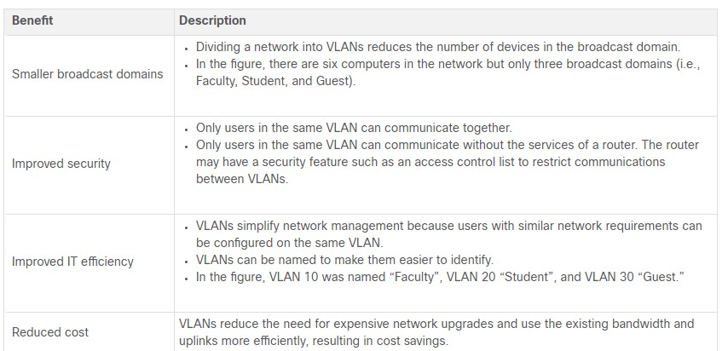

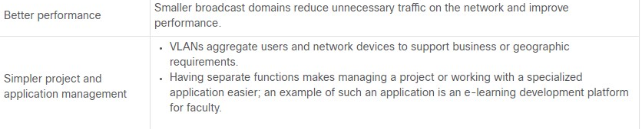

## Types of VLANs

VLANs are used for different reasons in modern networks. Some VLAN types are defined by traffic classes. Other types of VLANs are defined by the specific function that they serve.

**Default VLAN**

The default VLAN on a Cisco switch is VLAN 1. Therefore, all switch ports are on VLAN 1 unless it is explicitly configured to be on another VLAN. By default, all Layer 2 control traffic is associated with VLAN 1.

Important facts to remember about VLAN 1 include the following:

* All ports are assigned to VLAN 1 by default.
* The native VLAN is VLAN 1 by default.
* The management VLAN is VLAN 1 by default.
* VLAN 1 cannot be renamed or deleted.

For instance, in the **show vlan brief** output, all ports are currently assigned to the default VLAN 1. No native VLAN is explicitly assigned and no other VLANs are active; therefore, the network is designed with the native VLAN the same as the management VLAN. This is considered a security risk.

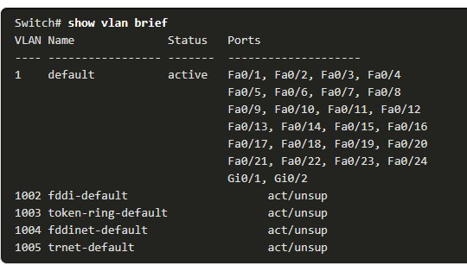

**Data VLAN**

Data VLANs are VLANs configured to separate user-generated traffic. They are referred to as user VLANs because they separate the network into groups of users or devices. A modern network would have many data VLANs depending on organizational requirements. Note that voice and network management traffic should not be permitted on data VLANs.

**Native VLAN**

User traffic from a VLAN must be tagged with its VLAN ID when it is sent to another switch. Trunk ports are used between switches to support the transmission of tagged traffic. Specifically, an 802.1Q trunk port inserts a 4-byte tag in the Ethernet frame header to identify the VLAN to which the frame belongs.

A switch may also have to send untagged traffic across a trunk link. Untagged traffic is generated by a switch and may also come from legacy devices. The 802.1Q trunk port places untagged traffic on the native VLAN. The native VLAN on a Cisco switch is VLAN 1 (i.e., default VLAN).

It is a best practice to configure the native VLAN as an unused VLAN, distinct from VLAN 1 and other VLANs. In fact, it is not unusual to dedicate a fixed VLAN to serve the role of the native VLAN for all trunk ports in the switched domain.

**Management VLAN**

A management VLAN is a data VLAN configured specifically for ***network management traffic*** including :

* **SSH,**
* **Telnet**
* **HTTPS**
* **HTTP**
* **SNMP.**

By default, VLAN 1 is configured as the management VLAN on a Layer 2 switch.

**Voice VLAN**

A separate VLAN is needed to support Voice over IP (VoIP). VoIP traffic requires the following:

* Assured bandwidth to ensure voice quality
* Transmission priority over other types of network traffic
* Ability to be routed around congested areas on the network
* Delay of less than 150 ms across the network

To meet these requirements, the entire network has to be designed to support VoIP.

In the figure, VLAN 150 is designed to carry voice traffic. The student computer PC5 is attached to the Cisco IP phone, and the phone is attached to switch S3. PC5 is in VLAN 20, which is used for student data.

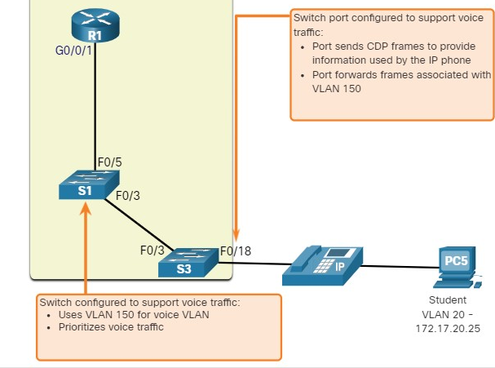

3.1.4

## Packet Tracer - Who Hears the Broadcast?

In this Packet Tracer activity, you will complete the following objectives:

* Part 1: Observe Broadcast Traffic in a VLAN Implementation
* Part 2: Complete Review Questions

1. True or False? VLANs improve network performance by segmenting broadcast domains.



True



False

***ANS: The correct answer is True. A VLAN is a logical broadcast domain that can span multiple LAN segments. This can improve network performance by segmenting large broadcast domains into smaller broadcast domains. Broadcast frames are not forwarded between VLANs.***

2. True or False? VLANs can improve security by isolating sensitive data from the rest of the network.



True



False

***ANS: The correct answer is True. Traffic generated within a VLAN remains within that VLAN and is completely separated from other parts of the network.***

3. Which type of VLAN is assigned to 802.1Q trunk ports to carry untagged traffic?



default



native



data



Management

**ANS: The native VLAN is assigned to 802.1Q trunk ports to carry untagged traffic.**

4. True or False? It is a best practice to configure the native VLAN as VLAN 1.



True



False

**ANS: The correct answer is False. By default, the native VLAN is VLAN 1, however it is best practice to configure the native VLAN to be an unused VLAN.**

5. Which is true of VLAN 1? (Choose all that apply.)



All switch ports are assigned to VLAN 1 by default.



The native VLAN is VLAN 1 by default.



The management VLAN is VLAN 1 by default.



VLAN 1 cannot be renamed or deleted.

**ANS: All answers are True. VLAN 1 is the default native and management VLAN. All switch ports are by default assigned to this VLAN. VLAN 1 cannot be renamed nor deleted.**

**VLANS IN A MULTI-SWITCHED ENVIRONMENT**

3.2.1

Defining VLAN Trunks

VLANs would not be very useful without VLAN trunks. VLAN trunks allow all VLAN traffic to propagate between switches.

This enables devices connected to different switches but in the same VLAN to communicate without going through a router.

***A trunk*** is a point-to-point link between two network devices that carries more than one VLAN.

A VLAN trunk extends VLANs across an entire network. Cisco supports ***IEEE 802.1Q*** for coordinating trunks on Fast Ethernet, Gigabit Ethernet, and 10-Gigabit Ethernet interfaces.

A VLAN trunk does not belong to a specific VLAN. Instead, it is a conduit for multiple VLANs between switches and routers. A trunk could also be used between a network device and server or another device that is equipped with an appropriate 802.1Q-capable NIC. By default, on a Cisco Catalyst switch, all VLANs are supported on a trunk port.

In the figure, the highlighted links between switches S1 and S2, and S1 and S3 are configured to transmit traffic coming from VLANs 10, 20, 30, and 99 (i.e., native VLAN) across the network. This network could not function without VLAN trunks.

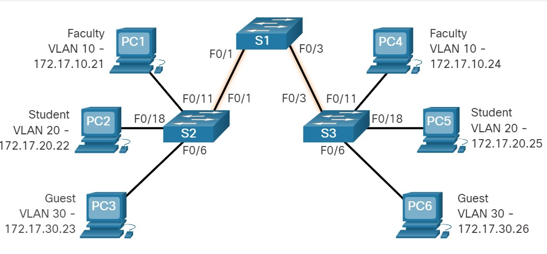

3.2.2

Network without VLANs

When a switch receives a broadcast frame on one of its ports, it forwards the frame out all other ports except the port where the broadcast was received.

In the animation, the entire network is configured in the same subnet (172.17.40.0/24) and no VLANs are configured. As a result, when the faculty computer (PC1) sends out a broadcast frame, switch S2 sends that broadcast frame out all of its ports. Eventually the entire network receives the broadcast because the network is one broadcast domain.

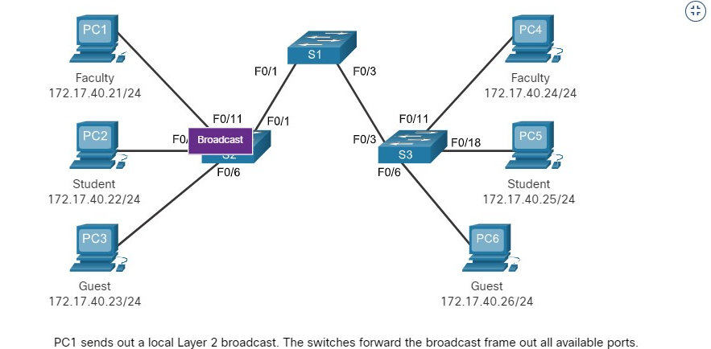

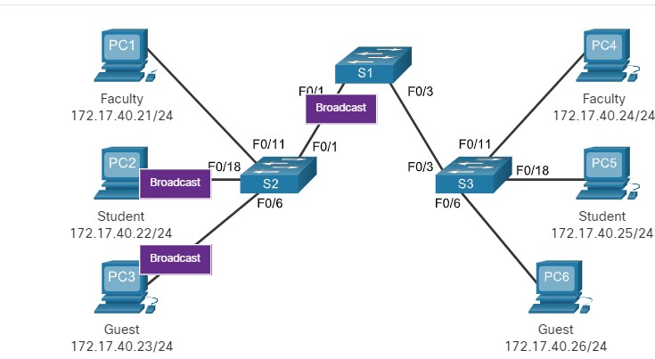

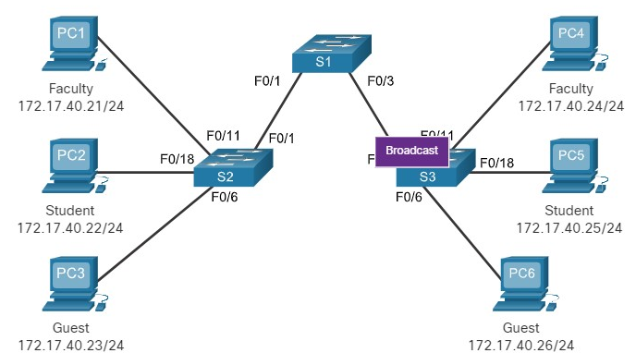

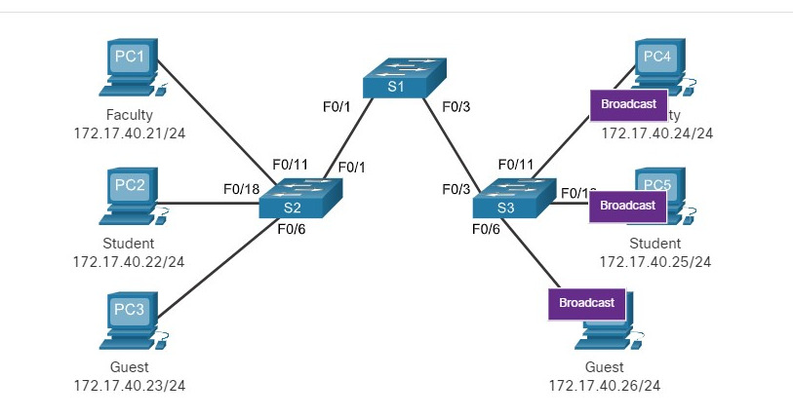

3.2.3

Network with VLANs

VLANs are associated with and configured on individual switch ports.

Devices attached to those ports have no concept of VLANs. However, these devices are configured with IP addressing and are members of a specific IP network. This is where the connection between VLAN and IP network is apparent.

A VLAN is the equivalent to an ***IP network (or subnet).*** VLANs are configured on the switch, whereas IP addressing is configured on the device.

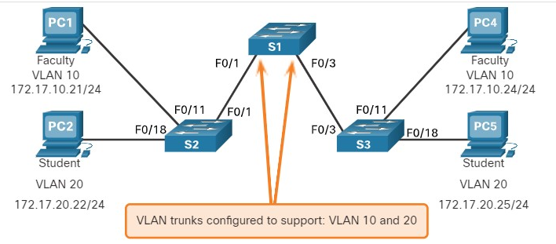

Click Play in the animation to see that the same network has now been segmented using two VLANs. Faculty devices are assigned to VLAN 10 and student devices are assigned to VLAN 20. When a broadcast frame is sent from the faculty computer, PC1, to switch S2, the switch forwards that broadcast frame only to those switch ports configured to support VLAN 10.

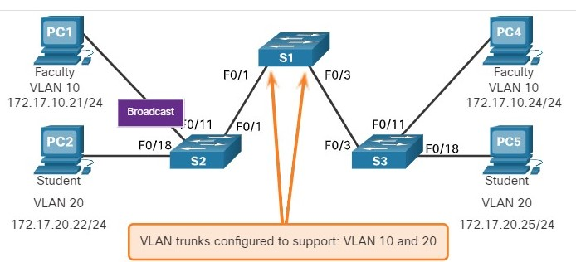

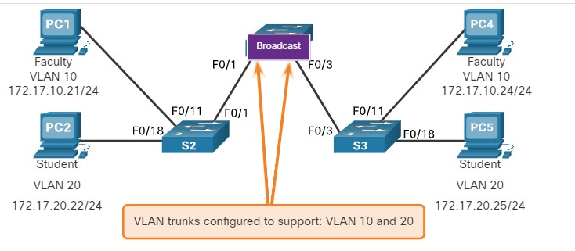

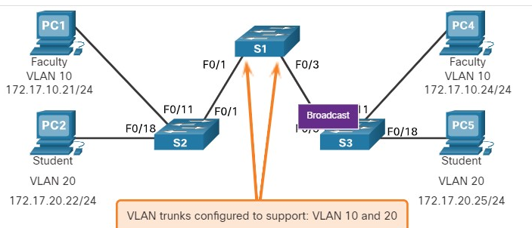

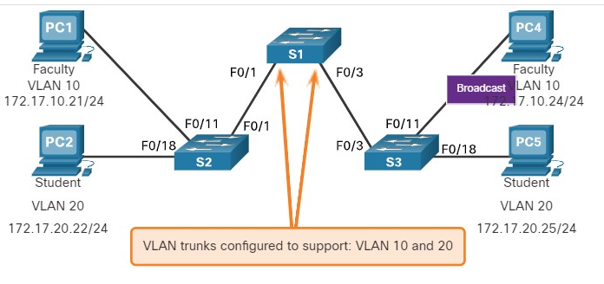

The ports that comprise the connection between switches S2 and S1 (ports F0/1), and between S1 and S3 (ports F0/3) are trunks and have been configured to support all the VLANs in the network.

When S1 receives the broadcast frame on port F0/1, S1 forwards that broadcast frame out of the only other port configured to support VLAN 10, which is port F0/3. When S3 receives the broadcast frame on port F0/3, it forwards that broadcast frame out the only other port configured to support VLAN 10, which is port F0/11. The broadcast frame arrives at the only other computer in the network configured in VLAN 10, which is faculty computer PC4.

When VLANs are implemented on a switch, the transmission of unicast, multicast, and broadcast traffic from a host in a particular VLAN are restricted to the devices that are in that VLAN.

## VLAN Identification with a Tag

The standard Ethernet frame header does not contain information about the VLAN to which the frame belongs.

Therefore, when Ethernet frames are placed on a trunk, information about the VLANs to which they belong must be added.

This process, called ***tagging***, is accomplished by using the IEEE 802.1Q header, specified in the IEEE 802.1Q standard

. The 802.1Q header includes a 4-byte tag inserted within the original Ethernet frame header, specifying the VLAN to which the frame belongs.

When the switch receives a frame on a port configured in access mode and assigned a VLAN, the switch inserts a VLAN tag in the frame header, recalculates the Frame Check Sequence (FCS), and sends the tagged frame out of a trunk port.

**VLAN Tag Field Details**

As shown in the figure, the VLAN tag control information field consists of a Type field, a Priority field, a Canonical Format Identifier field, and VLAN ID field:

* **Type** - A 2-byte value called the tag protocol ID (TPID) value. For Ethernet, it is set to hexadecimal 0x8100.
* **User priority** - A 3-bit value that supports level or service implementation.
* **Canonical Format Identifier (CFI)** - A 1-bit identifier that enables Token Ring frames to be carried across Ethernet links.
* **VLAN ID (VID)** - A 12-bit VLAN identification number that supports up to 4096 VLAN IDs.

After the switch inserts the tag control information fields, it recalculates the FCS values and inserts the new FCS into the frame.

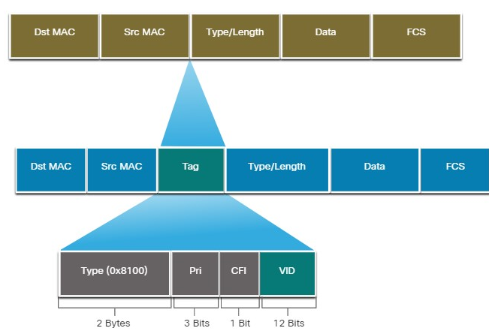

## Native VLANs and 802.1Q Tagging

The IEEE 802.1Q standard specifies a native VLAN for trunk links, which defaults to VLAN 1.

When an ***untagged frame*** arrives on a trunk port it is assigned to the ***native VLAN. Management*** frames that are sent between switches is an example of traffic that is typically untagged. If the link between two switches is a trunk, the switch sends the untagged traffic on the native VLAN.

**Tagged Frames on the Native VLAN**

Some devices that support trunking add a VLAN tag to native VLAN traffic. Control traffic sent on the ***native VLAN*** should not be tagged.

If an 802.1Q trunk port receives a tagged frame with the VLAN ID that is the same as the native VLAN, it drops the frame.

Consequently, when configuring a switch port on a Cisco switch, configure devices so that they do not send tagged frames on the native VLAN. Devices from other vendors that support tagged frames on the native VLAN include IP phones, servers, routers, and non-Cisco switches.

**Untagged Frames on the Native VLAN**

When a Cisco switch trunk port receives untagged frames (which are unusual in a well-designed network), it forwards those frames to the native VLAN. If there are no devices associated with the native VLAN (which is not unusual) and there are no other trunk ports (which is not unusual), then the frame is dropped.

The default native VLAN is VLAN 1. When configuring an 802.1Q trunk port, a default Port VLAN ID (PVID) is assigned the value of the native VLAN ID.

All untagged traffic coming in or out of the 802.1Q port is forwarded based on the PVID value. For example, if VLAN 99 is configured as the native VLAN, the PVID is 99 and all untagged traffic is forwarded to VLAN 99. If the native VLAN has not been reconfigured, the PVID value is set to VLAN 1.

In the figure, PC1 is connected by a hub to an 802.1Q trunk link.

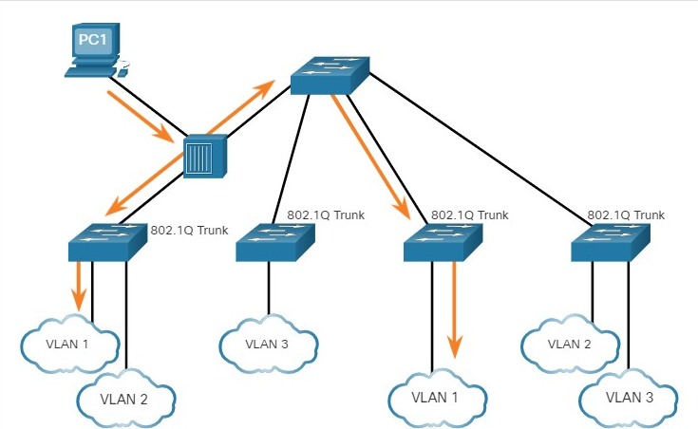

PC1 sends untagged traffic, which the switches associate with the native VLAN configured on the trunk ports, and forward accordingly.

Tagged traffic on the trunk received by PC1 is dropped. This scenario reflects poor network design for several reasons: it uses a hub, it has a host connected to a trunk link, and it implies that the switches have access ports assigned to the native VLAN.

It also illustrates the motivation for the IEEE 802.1Q specification for native VLANs as a means of handling legacy scenarios.

## Voice VLAN Tagging

A separate voice VLAN is required to support VoIP. This enables quality of service (QoS) and security policies to be applied to voice traffic.

A Cisco IP phone connects directly to a switch port. An IP host can connect to the IP phone to gain network connectivity as well.

The access port connected to the Cisco IP phone can be configured to use two separate VLANs. One VLAN is for voice traffic and the other is a data VLAN to support the host traffic. The link between the switch and the IP phone simulates a trunk link to carry both voice VLAN traffic and data VLAN traffic.

Specifically, the Cisco IP Phone contains an integrated three-port 10/100 switch. The ports provide dedicated connections to the following devices:

* Port 1 connects to the switch or other VoIP device.
* Port 2 is an internal 10/100 interface that carries the IP phone traffic.
* Port 3 (access port) connects to a PC or other device.

The switch access port sends CDP packets instructing the attached IP phone to send voice traffic in one of three ways. The method used varies based on the type of traffic:

* Voice VLAN traffic must be tagged with an appropriate Layer 2 class of service (CoS) priority value
* Access VLAN traffic can also be tagged with a Layer 2 CoS priority value
* Access VLAN is not tagged (no Layer 2 CoS priority value)

In the figure, the student computer PC5 is attached to a Cisco IP phone, and the phone is attached to switch S3. VLAN 150 is designed to carry voice traffic, while PC5 is in VLAN 20, which is used for student data.

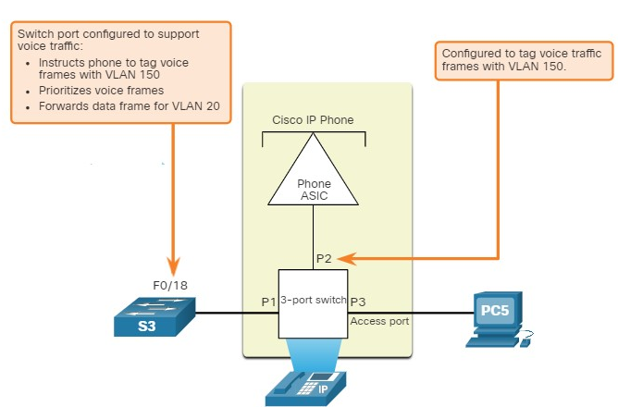

## Voice VLAN Verification Example

The example output for the **show interface fa0/18 switchport** command is shown. The highlighted areas in the sample output show the F0/18 interface configured with a VLAN that is configured for data (VLAN 20), and a VLAN configured for voice (VLAN 150).

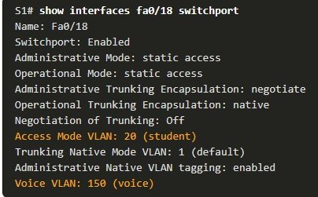

3.2.8

Packet Tracer - Investigate a VLAN Implementation(pending 3.2.8)

In this activity, you will observe how broadcast traffic is forwarded by the switches when VLANs are configured and when VLANs are not configured.

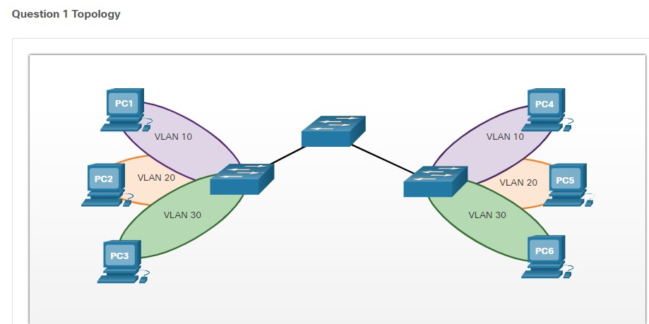

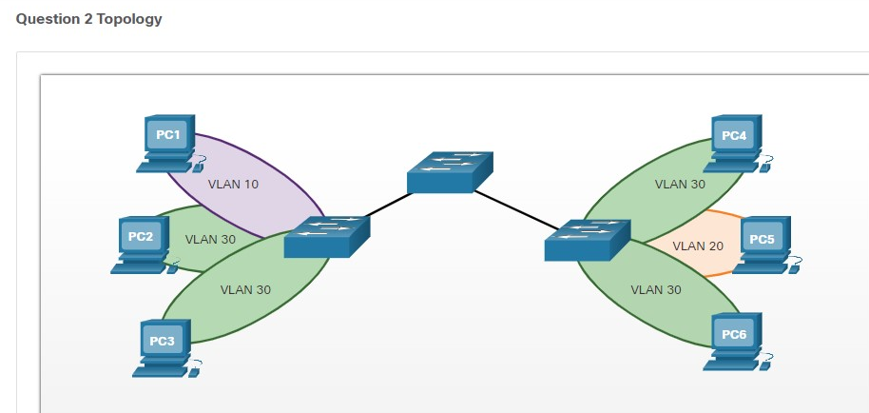

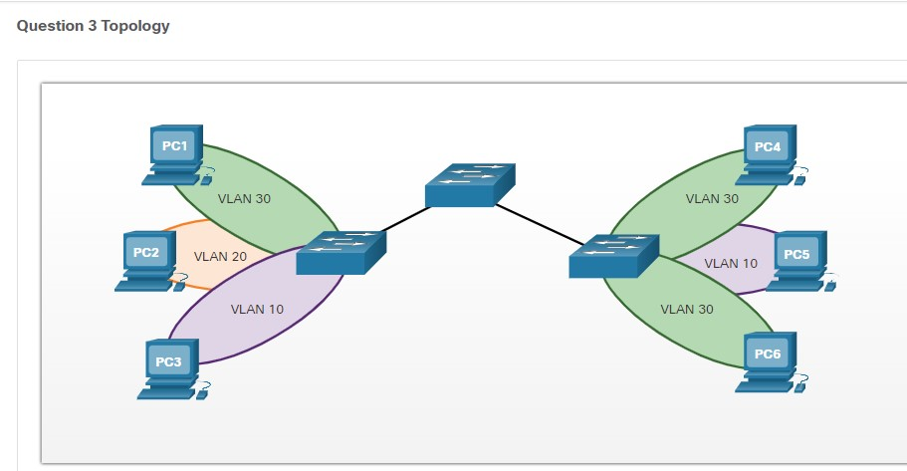

Top of Form

1. Refer to the exhibit **Question 1 Topology**. PC1 sends an ARP broadcast frame. Which PC will receive the ARP broadcast frame?



PC2



PC3



PC4



PC5



PC6

**ANS: PC4 will be the only PC to receive the broadcast from PC1. This is because PC1 and PC4 are in the same VLAN, VLAN 10 and broadcasts are contained within a VLAN.**

1. Refer to the exhibit **Question 2 Topology**. PC2 sends an ARP broadcast frame. Which PCs will receive the ARP broadcast frame? (Choose all that apply.)



PC1



PC3



PC4



PC5



PC6

**ANS: PC3, PC4, and PC6 will be the only PCs to receive the broadcast from PC2. This is because PC3, PC4, and PC6 are in the same VLAN, VLAN 30 and broadcasts are contained within a VLAN.**

1. Refer to the exhibit **Question 3 Topology**. PC3 sends an ARP broadcast frame. Which PC will receive the ARP broadcast frame?



PC1



PC2



PC4



PC5



PC6

**ANS: PC5 will be the only PC to receive the broadcast from PC3. This is because PC3 and PC5 are in the same VLAN, VLAN 10 and broadcasts are contained within a VLAN.**

**VLAN CONCEPTS**

# VLAN Concept

## LAN switches and BUM traffic

Before understanding the VLAN concept, you must first have an understanding of two core concepts about the Ethernet standard - what is a broadcast domain and what is BUM traffic.

Let's start with the BUM data type. BUM stands for **broadcast,** **unknown unicast**, and **multicast**.

When a LAN switch receives a frame that belongs to one of these types, it sends the frame to all its ports except the port it received the frame on. This behavior is shown on figure 1.

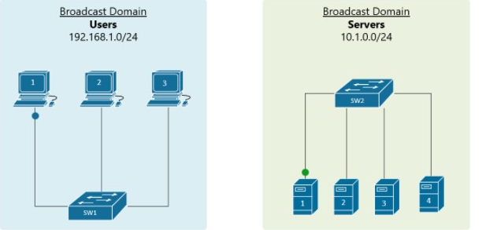

A **broadcast domain** includes all connected devices that get a copy of any broadcast, unknown unicast, or multicast (BUM) frame being sent

. In the above figure, the blue LAN on the left is one broadcast domain and the green LAN on the right side is another broadcast domain.

A general rule of thumb is that a single LAN is equal to a Broadcast Domain is equal to a Subnet.



By default, all interfaces on a Cisco switch are in the same broadcast domain. Therefore, when a broadcast frame is received on any switch port, the switch forwards it out to all its other ports.

Having that logic in mind, to create two separate LANs (like one for servers and one for users), you must use ***two different switches*** as shown in figure 1.

Тhis approach is not scalable, imagine if your organization want to have thousand separate LANs, it has to have thousands of physical switches. This scaling limitation is the reason why Virtual LANs were introduced.

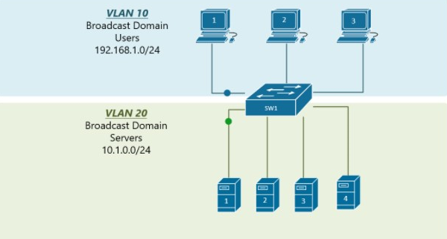

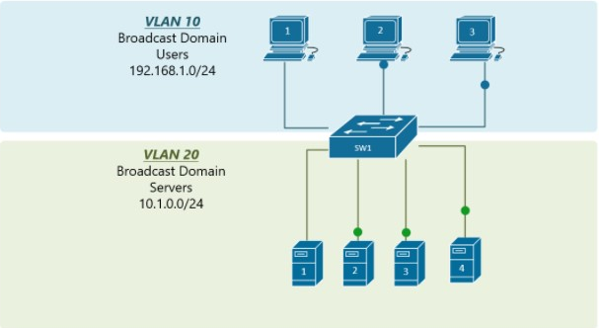

By using VLANs, a ***single switch*** can act as two logical switches or creating two broadcast domains.

This is done on a port-by-port basis. Using figure 2 as an example, the ports where the users are connected, are configured to be part of VLAN10 (or in other words to be connected to virtual switch 10) and the ports where the servers are connected to, are configured to be part of VLAN20 (or in other words to be connected to virtual switch 20).

The switch will then never forward a frame send by any user to any of the servers and vice-versa because they are part of ***different broadcast domains.***

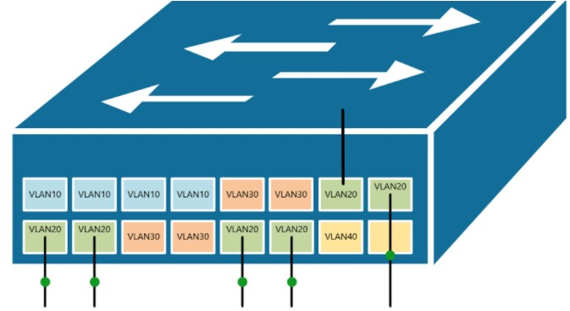

**Benefits of using VLANs**

Using VLANs not only improves the scaling of the campus LAN. It has many more advantages such as:

* **It improves the security** by reducing the number of end-stations that receive copies of BUM traffic.
* **It creates smaller fault domains** by isolating different groups of devices in separate broadcast domains.
* **It reduces the CPU overhead** on each device in the LAN by limiting the number of broadcast frames received.
* **It improves network performance** and speed of failure recovering.

**VLAN CONFIGURATIONS**

3.3.1

## VLAN Ranges on Catalyst Switches

Creating VLANs, like most other aspects of networking, is a matter of entering the appropriate commands. This topic details how to configure and verify different types of VLANs.

Different Cisco Catalyst switches support various numbers of VLANs. The number of supported VLANs is large enough to accommodate the needs of most organizations.

For example, the Catalyst 2960 and 3650 Series switches support over ***4,000 VLANs***. Normal range VLANs on these switches are numbered 1 to 1,005 and extended range VLANs are numbered 1,006 to 4,094. The figure illustrates the default VLANs on a Catalyst 2960 switch running Cisco IOS Release 15.x.

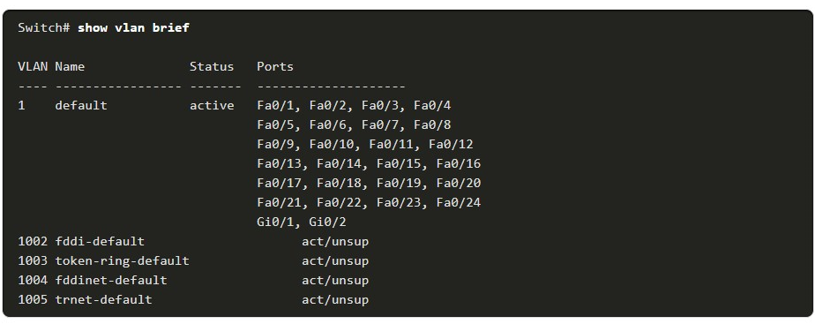

**Normal Range VLANs**

The following are characteristics of normal range VLANs:

* They are used in all small- and medium-sized business and enterprise networks.
* They are identified by a VLAN ID between 1 and 1005.
* IDs 1002 through 1005 are reserved for legacy network technologies (i.e., Token Ring and Fiber Distributed Data Interface).
* IDs 1 and 1002 to 1005 are automatically created and cannot be removed.
* Configurations are stored in the ***switch flash memory*** in a VLAN database file called ***vlan.dat.***
* When configured, VLAN trunking protocol (VTP), helps synchronize the VLAN database between switches.

**Extended Range VLANs**

The following are characteristics of extended range VLANs:

* They are used by service providers to service multiple customers and by global enterprises large enough to need extended range VLAN IDs.
* They are identified by a VLAN ID between 1006 and 4094.
* Configurations are saved, by default, in the running configuration.
* They support fewer VLAN features than normal range VLANs.
* Requires VTP transparent mode configuration to support extended range VLANs.

**Note**: 4096 is the upper boundary for the number of VLANs available on Catalyst switches, because there are 12 bits in the VLAN ID field of the IEEE 802.1Q header.

3.3.2

## VLAN Creation Commands

When configuring normal range VLANs, the configuration details are stored in flash memory on the switch in a file called vlan.dat.

Flash memory is persistent and does not require the **copy running-config startup-config** command.

However, because other details are often configured on a Cisco switch at the same time that VLANs are created, it is good practice to save running configuration changes to the startup configuration.

The table displays the Cisco IOS command syntax used to add a VLAN to a switch and give it a name. Naming each VLAN is considered a best practice in switch configuration.

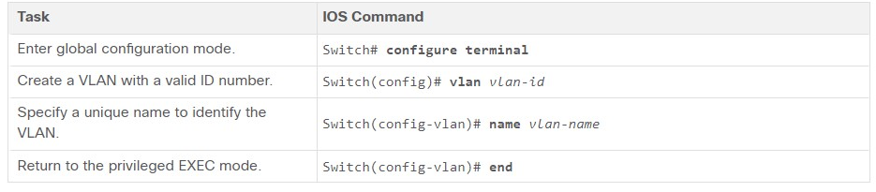

3.3.3

VLAN Creation Example

In the topology, the student computer (PC2) has not been associated with a VLAN yet, but it does have an IP address of 172.17.20.22, which belongs to VLAN 20.

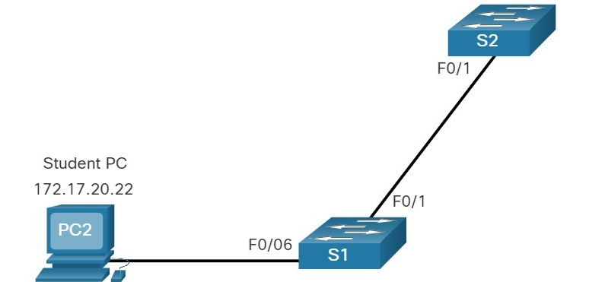

The example shows how the student VLAN (VLAN 20) is configured on switch S1.

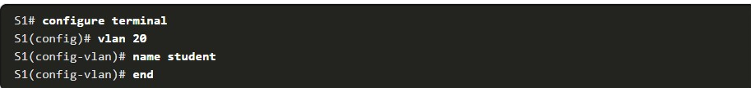

**Note**: In addition to entering a single VLAN ID, a series of VLAN IDs can be entered separated by commas, or a range of VLAN IDs separated by hyphens using the **vlan** vlan-id command.

For example, entering the **vlan 100,102,105-107** global configuration command would create VLANs 100, 102, 105, 106, and 107**.**

## VLAN Port Assignment Commands

After creating a VLAN, the next step is to assign ports to the VLAN.

The table displays the syntax for defining a port to be an access port and assigning it to a VLAN. The **switchport mode access** command is optional, but strongly recommended as a security best practice.

With this command, the interface changes to strictly access mode. Access mode indicates that the port ***belongs to a single VLAN*** and will not negotiate to become a trunk link.

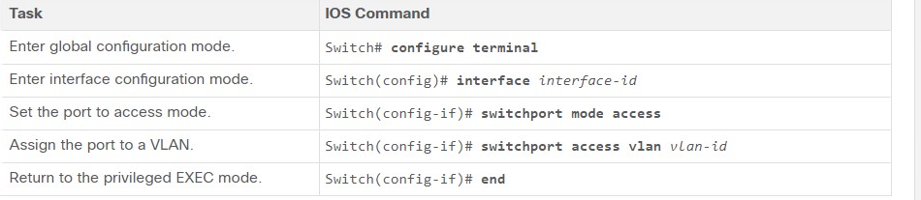

 Use the **interface range** command to simultaneously configure multiple interfaces.

3.3.5

VLAN Port Assignment Example

In the figure, port F0/6 on switch S1 is configured as an access port and assigned to VLAN 20. Any device connected to that port will be associated with VLAN 20. Therefore, in our example, PC2 is in VLAN 20.

The example shows the configuration for S1 to assign F0/6 to VLAN 20.

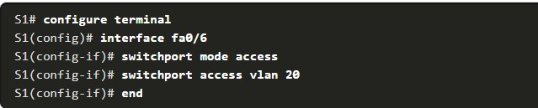

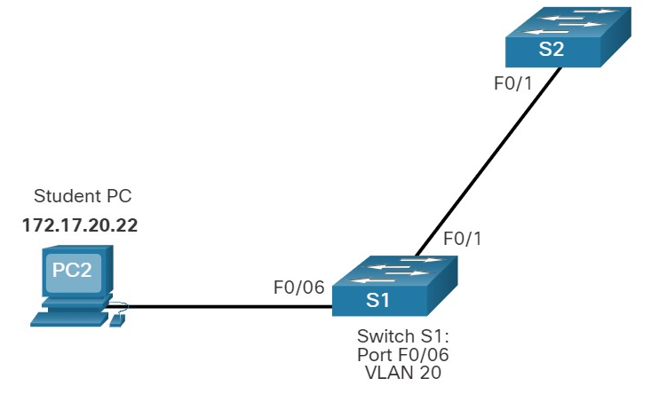

VLANs are configured on the switch port and not on the end device. PC2 is configured with an IPv4 address and subnet mask that ***is associated with the VLAN***, which is configured on the switch port. In this example, it is VLAN 20. When VLAN 20 is configured on other switches, the network administrator must configure the other student computers to be in the same subnet as PC2 ***(172.17.20.0/24).***

3.3.6

Data and Voice VLANs

An access port can belong to only one data VLAN at a time. However, a port can also be associated to a voice VLAN. For example, a port connected to an IP phone and an end device would be associated with two VLANs: one for voice and one for data.

Consider the topology in the figure. PC5 is connected to the Cisco IP phone, which in turn is connected to the FastEthernet 0/18 interface on S3. To implement this configuration, a data VLAN and a voice VLAN are created.

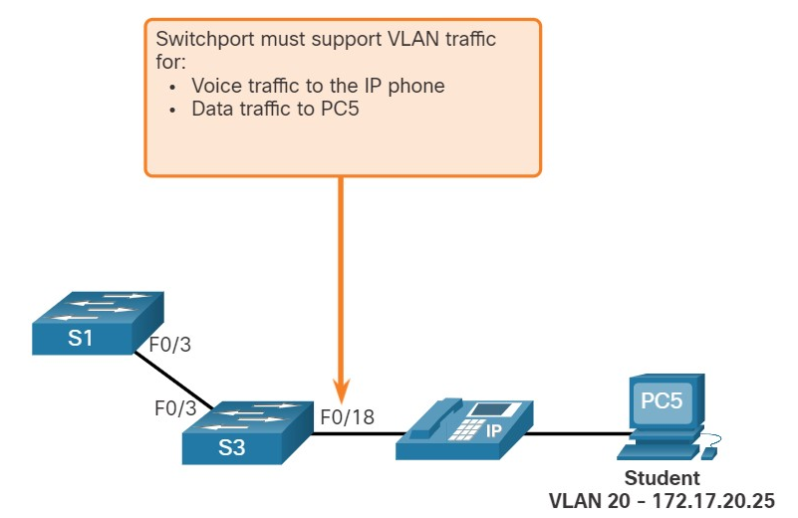

3.3.7

Data and Voice VLAN Example

Use the **switchport voice vlan** *vlan-id* interface configuration command to assign a voice VLAN to a port.

LANs supporting voice traffic typically also have quality of service (QoS) enabled. Voice traffic must be labeled as trusted as soon as it enters the network.

Use the **mls qos trust [cos | device cisco-phone | dscp | ip-precedence]** interface configuration command to set the trusted state of an interface, and to indicate which fields of the packet are used to classify traffic.

The configuration in the example creates the two VLANs (i.e., VLAN 20 and VLAN 150) and then assigns the F0/18 interface of S3 as a switchport in VLAN 20. It also assigns voice traffic to VLAN 150 and enables QoS classification based on the class of service (CoS) assigned by the IP phone.

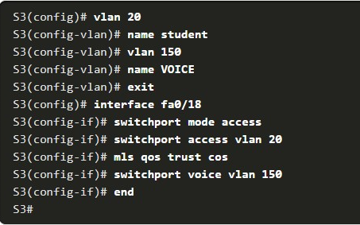

**Note:** The implementation of QoS is beyond the scope of this course.

The **switchport access vlan** command forces the creation of a VLAN if it does not already exist on the switch.

For example, VLAN 30 is not present in the **show vlan brief** output of the switch. If the **switchport access vlan 30** command is entered on any interface with no previous configuration, then the switch displays the following:



3.3.8

Verify VLAN Information

After a VLAN is configured, VLAN configurations can be validated using Cisco IOS **show** commands.

The **show vlan** command displays a list of all configured VLANs. The **show vlan** command can also be used with options. The complete syntax is **show vlan [brief** | **id** *vlan-id* | **name** *vlan-name* | **summary**].

The table describes the **show vlan** command options.

| **Task** | **Command Option** |
| --- | --- |
| Display VLAN name, status, and its ports one VLAN per line. | **brief** |
| Display information about the identified VLAN ID number. For *vlan-id*, the range is 1 to 4094. | **id** *vlan-id* |
| Display information about the identified VLAN name. The *vlan-name* is an ASCII string from 1 to 32 characters. | **name** *vlan-name* |
| Display VLAN summary information. | **summary** |

The **show vlan summary** command displays the count of all configured VLANs.

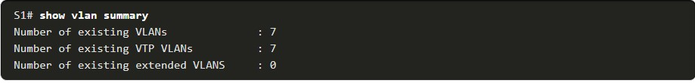

Other useful commands are the **show interfaces** interface-id **switchport** and the **show interfaces vlan** vlan-id command.

For example, the **show interfaces fa0/18 switchport** command can be used to confirm that the FastEthernet 0/18 port has been correctly assigned to data and voice VLANs.

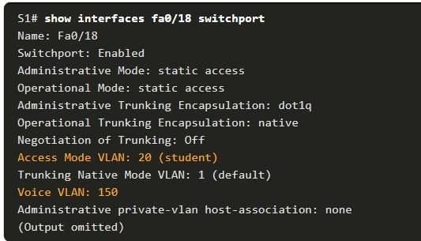

3.3.9

Change VLAN Port Membership

There are a number of ways to change VLAN port membership.

If the switch access port has been incorrectly assigned to a VLAN, then simply re-enter the **switchport access vlan** *vlan-id* interface configuration command with the correct VLAN ID. ]

For instance, assume Fa0/18 was incorrectly configured to be on the default VLAN 1 instead of VLAN 20. To change the port to VLAN 20, simply enter **switchport access vlan 20**.

To change the membership of a port back to the default VLAN 1, use the **no switchport access vlan** interface configuration mode command as shown.

In the output for example, Fa0/18 is configured to be on the default VLAN 1 as confirmed by the **show vlan brief** command.

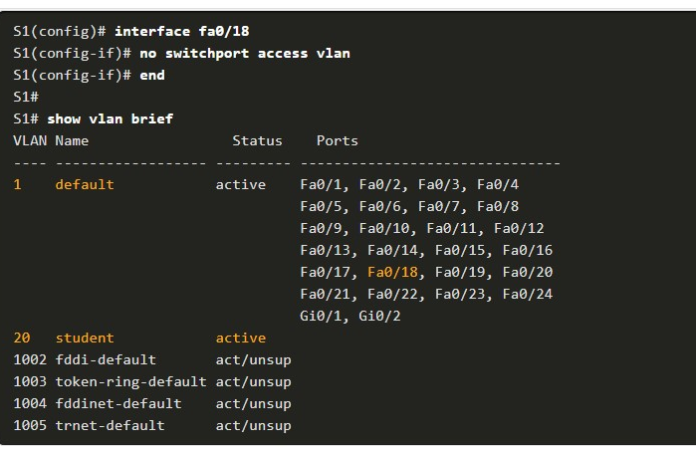

Notice that VLAN 20 is still active, even though no ports are assigned to it.

The **show interfaces f0/18 switchport** output can also be used to verify that the access VLAN for interface F0/18 has been reset to VLAN 1 as shown in the output.

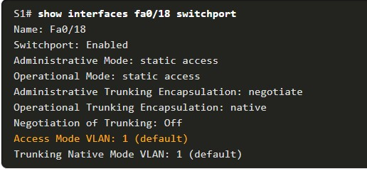

3.3.10

Delete VLANs

The **no vlan** *vlan-id* global configuration mode command is used to remove a VLAN from the switch vlan.dat file.

**Caution**: Before deleting a VLAN, reassign all member ports to a different VLAN first. Any ports that are not moved to an active VLAN are unable to communicate with other hosts after the VLAN is deleted and until they are assigned to an active VLAN.

The entire vlan.dat file can be deleted using the **delete flash:vlan.dat** privileged EXEC mode command.

The abbreviated command version (**delete vlan.dat**) can be used if the vlan.dat file has not been moved from its default location. After issuing this command and reloading the switch, any previously configured VLANs are no longer present. This effectively places the switch into its factory default condition with regard to VLAN configurations.

**Note**: To restore a Catalyst switch to its factory default condition, unplug all cables except the console and power cable from the switch. Then enter the **erase startup-config** privileged EXEC mode command followed by the **delete vlan.dat** command.

3.3.12

## Packet Tracer - VLAN Configuration(pending)

In this Packet Tracer activity, you will perform the following:

* Verify the Default VLAN Configuration
* Configure VLANs
* Assign VLANs to Port

**VLAN TRUNKING**

# VLAN Trunking

## Multiswitch broadcast domains

In the previous lesson, we explained that when a broadcast frame is received on any switch port, the switch forwards it out to all its other ports.

Having that in mind, if we connect two default setting switches, as shown in figure 1, any broadcast frame received by either switch is forwarded to the other one and then out all its ports.

Therefore a broadcast domain is not limited to one switch only, it includes all devices that get a copy of any broadcast frame, even if they are connected to other switches.

If we scale this logic to a LAN with tens of interconnected switches, we could have a broadcast domain consisting of hundred of end devices.

This at some point can contest the network with BUM traffic to the point that the LAN becomes unusable. Thus splitting the single broadcast domain into multiple smaller ones is even more important in large topologies for interconnected switches.



## VLAN on multiple switches

So if we apply the logic from the previous lesson, using virtual LANs we can split the switch topology into multiple broadcast domains as shown in figure 2.

There are multiple ways of doing this but let's start with the simplest one. This is done by configuring ports 1 through 4 of both switches to VLAN 10 and ports 5 through 9 to VLAN20.

Although it is a valid design and it works, it simply does not scale very well. It requires a physical link between the switches per VLAN. If the topology has to have 10+ VLANs, it would need 10+ physical cables between the switches, and you would use 10+ switch ports  (on each switch) for those links.

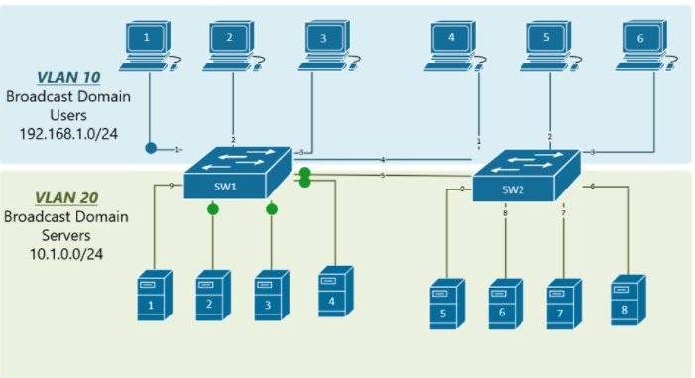

Obviously this design is applicable in topologies, where there are a few VLANs only. Nowadays in modern enterprise networks, there are tens of VLANs, so this way of spanning VLANs between switches is not applicable at scale.

## VLAN Trunking

In order to overcome this scaling limitation, we can use another Ethernet technology called ***VLAN trunking***.

It creates only one link between the switches that support as many VLAN as needed.

At the same time, it also keeps the VLAN traffic separate, so frames from VLAN 20 won't go to devices in VLAN 10 and vice-versa.

An example could be seen in figure 3. The link between switch 1 and switch 2 is a trunk link and you can see that both VLAN 10 and VLAN 20 pass through the link.

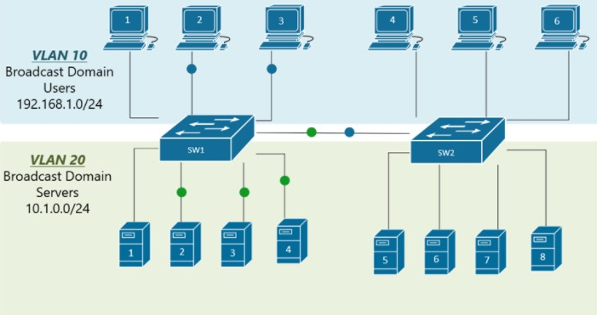

**Trunking protocols**

Two trunking protocols have been used on Cisco switches over the years

**- Inter-Switch Link (ISL)** and **IEEE 802.1Q**. ISL was a Cisco proprietary tagging protocol predesestor of 802.1Q, it has been depricated and is not used anymore. IEEE 802.1Q is the industry-standard trunking encapsulation at present and is typically the only one supported on modern switches.

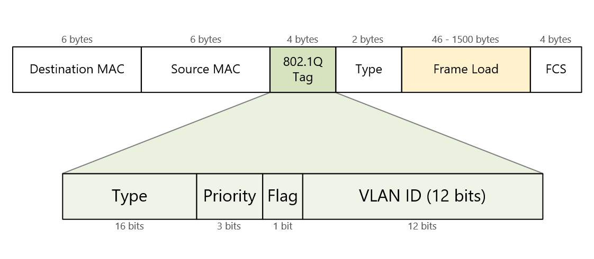

It is important to note that the tag adds 4 additional bytes to the Ethernet header of the frames. The most important field in the tag is the VLAN ID which is 12 bits long. It specifies the VLAN to which the frame belongs. Because values of 0x000 and 0xFFF are reserved, there are 4,094 possible VLAN numbers.

**VLAN Tagging**

VLAN trunking allows switches to forwards frames from different VLANs over a single link called **trunk**.

This is done by adding an additional header information called **tag**to the Ethernet frame.

The process of adding this small header is called **VLAN tagging**. If you look at Figure 4, end-station 1 is sending a broadcast frame.

When switch 1 receives the frame, it knows that this is a broadcast frame and it has to send it out all its ports. However, switch 1 must tell switch 2 that this frame belongs to VLAN10. So before sending the frame to switch 2, SW1 adds a VLAN header to the original ethernet frame, with VLAN number 10 as shown in figure4

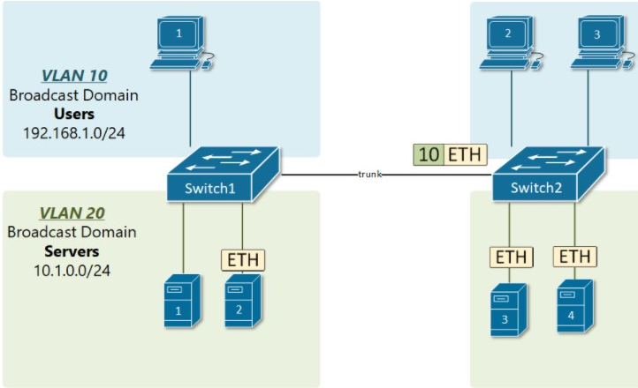.



When switch 2 receives the frame, it sees that the frame belongs to VLAN 10, then it removes the header and forwards to original ethernet frame to all its interfaces configured in VLAN10.

So in the given examples, when the ethernet frames are sent between the switches over the trunk link, they are **tagged**with VLAN header. When the receiving switch gets them, removes the VLAN tag and sends them to the clients in the VLAN, the frames are **untagged**.

3.4.1

Trunk Configuration Commands

Now that you have configured and verified VLANs, it is time to configure and verify VLAN trunks.

***A VLAN trunk*** is a Layer 2 link between two switches that carries traffic for all VLANs (unless the allowed VLAN list is restricted manually or dynamically).

To enable trunk links, configure the interconnecting ports with the set of interface configuration commands shown in the table.

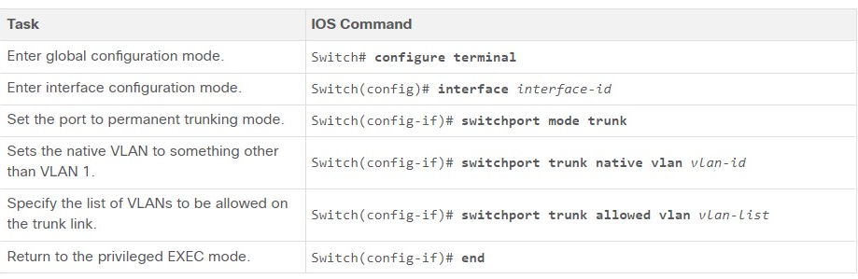

3.4.2

Trunk Configuration Example

In the figure, VLANs 10, 20, and 30 support the Faculty, Student, and Guest computers (PC1, PC2, and PC3). The F0/1 port on switch S1 is configured as a trunk port and forwards traffic for VLANs 10, 20, and 30. VLAN 99 is configured as the native VLAN.

A network topology shows three hosts in different VLANs connected to the same switch, S2. PC1 is on the Faculty VLAN 10 with address 172.17.10.21. PC2 is on the Student VLAN 20 with address 172.17.20.22. PC3 is on the Guest VLAN 30 with address 172.17.30.23. S2 is connected via port F0/1 to switch S1 at F0/1. This connection is labeled trunk.

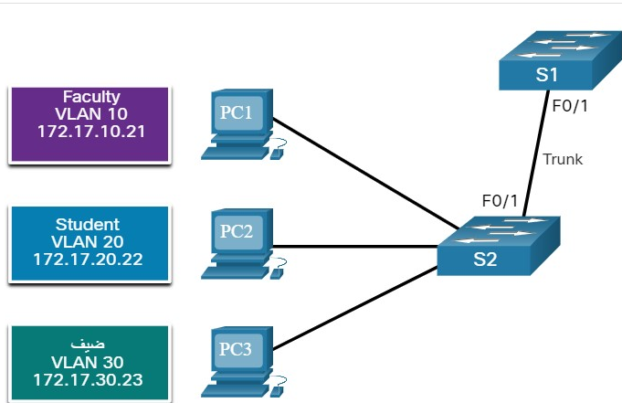

172.17.10.21StudeVLAN 20  
172.17.20.22ضيف  
VLAN 30  
172.17.30.23

The subnets associated with each VLAN are:

* VLAN 10 - Faculty/Staff - 172.17.10.0/24
* VLAN 20 - Students - 172.17.20.0/24
* VLAN 30 - Guests - 172.17.30.0/24
* VLAN 99 - Native - 172.17.99.0/24

The example shows the configuration of port F0/1 on switch S1 as a trunk port. The native VLAN is changed to VLAN 99 and the allowed VLAN list is restricted to 10, 20, 30, and 99.

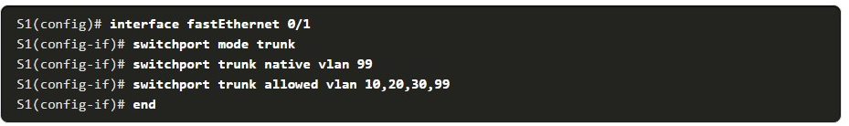

3.4.3

Verify Trunk Configuration

The switch output displays the configuration of switch port F0/1 on switch S1. The configuration is verified with the **show interfaces** *interface-ID* **switchport** command

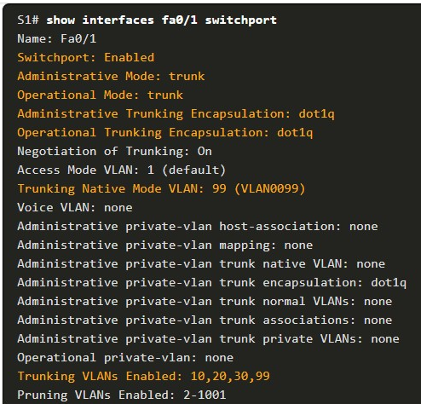

The top highlighted area shows that port F0/1 has its administrative mode set to **trunk**. The port is in trunking mode. The next highlighted area verifies that the native VLAN is VLAN 99. Further down in the output, the bottom highlighted area shows that VLANs 10, 20, 30, and 99 are enabled on the trunk.

**Note**: Another useful command for veryfing trunk interfaces is the **show interface trunk** command.

3.4.4

Reset the Trunk to the Default State

Use the **no switchport trunk allowed vlan** and the **no switchport trunk native vlan** commands to remove the allowed VLANs and reset the native VLAN of the trunk.

When it is reset to the default state, the trunk allows all VLANs and uses VLAN 1 as the native VLAN. The example shows the commands used to reset all trunking characteristics of a trunking interface to the default settings.

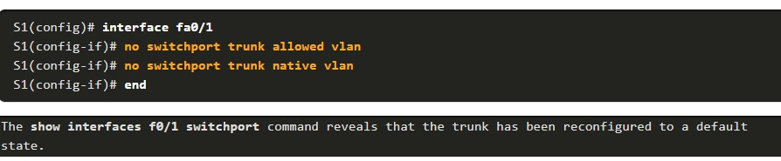

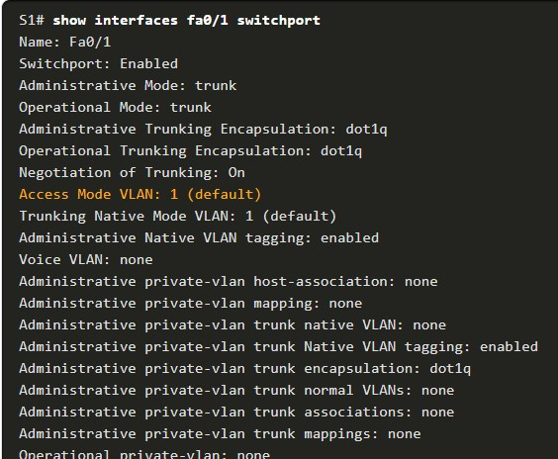

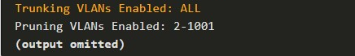

This sample output shows the commands used to remove the trunk feature from the F0/1 switch port on switch S1. The **show interfaces f0/1 switchport** command reveals that the F0/1 interface is now in static access mode.

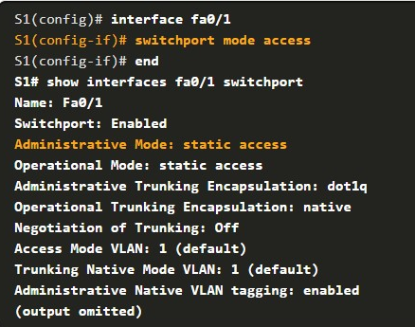

3.4.5

## Packet Tracer - Configure Trunks(pending)

In this Packet Tracer activity, you will perform the following:

* Verify VLANs
* Configure Trunks

3.4.6

## Lab - Configure VLANs and Trunking(pending)

##### **Skills Practice Opportunity**

You have the opportunity to practice the following skills:

* Part 1: Build the Network and Configure Basic Device Settings
* Part 2: Create VLANs and Assign Switch Ports
* Part 3: Maintain VLAN Port Assignments and the VLAN Database
* Part 4: Configure an 802.1Q Trunk Between the Switches

You can practice these skills using the Packet Tracer or lab equipment, if available.

**Packet Tracer - Physical Mode (PTPM)**

**DYNAMIC TRUNKING PROTOCOL (DTP)**

3.5.1

Introduction to DTP

Some Cisco switches have a proprietary protocol that lets them automatically negotiate trunking with a neighboring device.

This protocol is called ***Dynamic Trunking Protocol (DTP).*** DTP can speed up the configuration process for a network administrator.

Ethernet trunk interfaces support different trunking modes. An interface can be set to trunking or nontrunking, or to negotiate trunking with the neighbor interface. Trunk negotiation is managed by DTP, which operates on a point-to-point basis only, between network devices.

DTP is a Cisco proprietary protocol that is automatically enabled on Catalyst 2960 and Catalyst 3650 Series switches. DTP manages trunk negotiation only if the port on the neighbor switch is configured in a trunk mode that supports DTP. Switches from other vendors do not support DTP.

**Caution**: Some internetworking devices might forward DTP frames improperly, which can cause misconfigurations. To avoid this, turn off DTP on Cisco switch interfaces that are connected to devices that do not support DTP.

The default DTP configuration for Cisco Catalyst 2960 and 3650 switches is dynamic auto.

To enable trunking from a Cisco switch to a device that does not support DTP, use the **switchport mode trunk** and **switchport nonegotiate** interface configuration mode commands. This causes the interface to become a trunk, but it will not generate DTP frames.



To re-enable dynamic trunking protocol use the **switchport mode dynamic** **auto** command.



If the ports connecting two switches are configured to ignore all DTP advertisements with the **switchport mode trunk** and the **switchport nonegotiate** commands, the ports will stay in trunk port mode. If the connecting ports are set to dynamic auto, they will not negotiate a trunk and will stay in the access mode state, creating an inactive trunk link.

When configuring a port to be in trunk mode, use the **switchport mode trunk** command. Then there is no ambiguity about which state the trunk is in; it is always on.

3.5.2

Negotiated Interface Modes

The **switchport mode** command has additional options for negotiating the interface mode. The full command syntax is the following:



The options are described in the table.

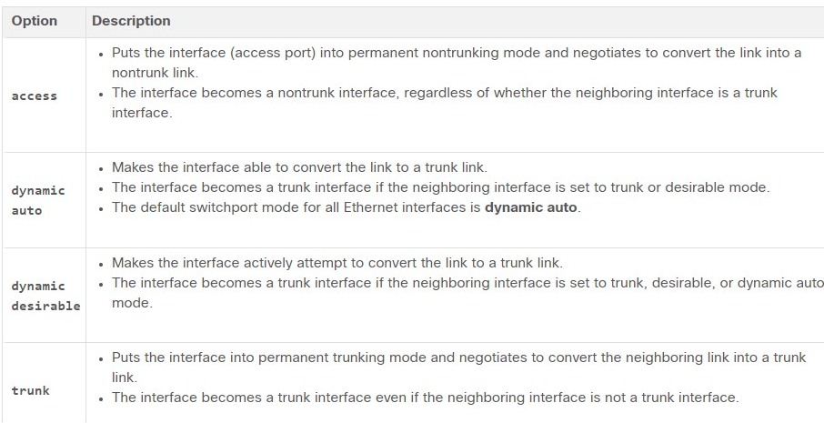

Use the **switchport nonegotiate** interface configuration command to stop DTP negotiation. The switch does not engage in DTP negotiation on this interface.

You can use this command only when the interface switchport mode is **access** or **trunk**. You must manually configure the neighboring interface as a trunk interface to establish a trunk link.

Results of a DTP Configuration

The table illustrates the results of the DTP configuration options on opposite ends of a trunk link connected to Catalyst 2960 switch ports. Best practice is to configure trunk links statically whenever possible.

|  | **Dynamic Auto** | **Dynamic Desirable** | **Trunk** | **Access** |
| --- | --- | --- | --- | --- |
| **Dynamic Auto** | Access | Trunk | Trunk | Access |
| **Dynamic Desirable** | Trunk | Trunk | Trunk | Access |
| **Trunk** | Trunk | Trunk | Trunk | Limited connectivity |
| **Access** | Access | Access | Limited connectivity | Access |

3.5.4

Verify DTP Mode

The default DTP mode is dependent on the Cisco IOS Software version and on the platform. To determine the current DTP mode, issue the **show dtp interface** command as shown in the output.

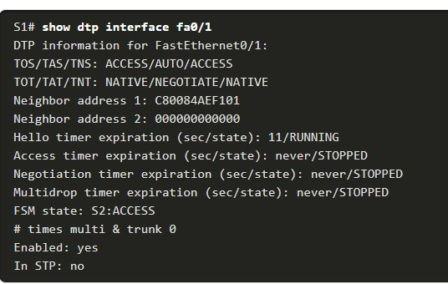

**Note**: A general best practice is to set the interface to **trunk** and **nonegotiate** when a trunk link is required. On links where trunking is not intended, DTP should be turned off.

3.5.5

Packet Tracer - Configure DTP(pending)

In this Packet Tracer activity, you will configure and verify DTP.

## Switch interface modes

Each switch interface can operate as **access**or **trunk**port. Because in typical LAN deployment, there are hundreds or even thousands of switch ports, there is a protocol called **Dynamic Trunking Protocol (DTP)** that helps network administrators set the operational mode of interfaces automatically.

By **default,** all Cisco switch ports are in operational state **dynamic auto**, which means that this Dynamic Trunking Protocol (DTP) is listening and trying to understand what is configured on the other side of the cable, and based on that to decide whether to become an access or trunk port.

For example, if we have a link between SW1 and SW2, if we configure the interface on SW1 to be a trunk port, DTP will advertise this to the other side and the interface on SW2 will automatically set itelf in trunk mode and a trunk link will be formed between the switches.

| **Mode** | **Behavior** |
| --- | --- |
| **switchport mode dynamic auto** | DEFAULT MODE for layer 2 interfaces of Cisco switches  ***Passively waiting*** to convert the port into a **trunk**. (DTP listening for messages from the far side saying "let's form a trunk")  Becomes a trunk if the other side of the link is configured with **trunk**or **dynamic desirable** mode |
| **switchport mode dynamic desirable** | Actively trying to convert the link to a **trunk**. (DTP actively sending messages to the far side saying "let's form a trunk")  Becomes a trunk if the other side of the link is configured with **trunk**or **dynamic desirable** or **dynamic auto.** |
| **switchport mode access** | The interface becomes an **access port**.  DTP negotiates the link as nontrunk link. |
| **switchport mode trunk** | The interface becomes a **trunk port**.  DTP negotiates the link as trunk link. (DTP actively sending messages to the far side saying "let's form a trunk") |
| **switchport mode nonegotiate** | Disables the Dynamic Trunking Protocol (DTP).  Interface mode is configured manually. |

As you can see there are quite a few switchport operational modes, so there are several possible combination for both ends of a link between two switches. Depending on the configuration of both sides the switches could form a trunk link or not. All combination are shown in Figure 6.

| Table 1. Switchport modes | |
| --- | --- |
| **Mode** | **Behaviour** |
| **switchport mode dynamic auto** | DEFAULT MODE for layer 2 interfaces of Cisco switches  Passively waiting to convert the port into a **trunk**. (DTP listening for messages from the far side saying "let's form a trunk")  Becomes a trunk if the other side of the link is configured with **trunk**or **dynamic desirable** mode |
| **switchport mode dynamic desirable** | Actively trying to convert the link to a **trunk**. (DTP actively sending messages to the far side saying "let's form a trunk")  Becomes a trunk if the other side of the link is configured with **trunk**or **dynamic desirable** or **dynamic auto.** |
| **switchport mode access** | The interface becomes an **access port**.  DTP negotiates the link as nontrunk link. |
| **switchport mode trunk** | The interface becomes a **trunk port**.  DTP negotiates the link as trunk link. (DTP actively sending messages to the far side saying "let's form a trunk") |
| **switchport mode nonegotiate** | Disables the Dynamic Trunking Protocol (DTP).  Interface mode is configured manually. |

As you can see there are quite a few switchport operational modes, so there are several possible combination for both ends of a link between two switches. Depending on the configuration of both sides the switches could form a trunk link or not. All combination are shown in Figure 6.

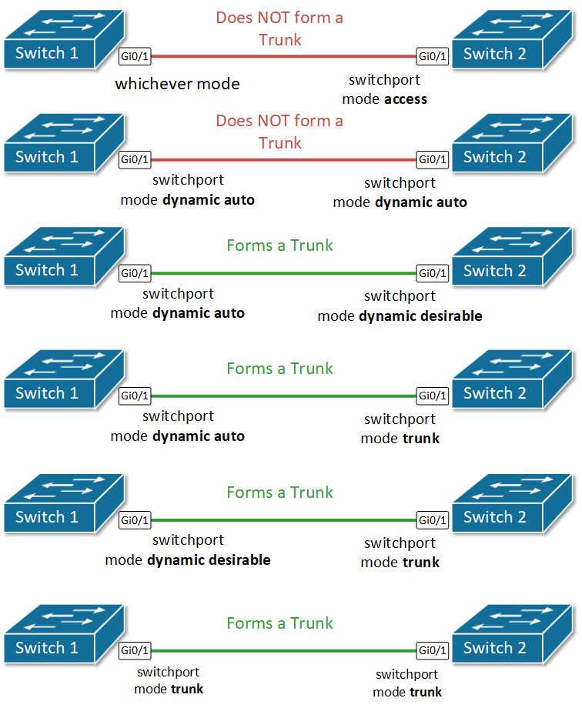

## Configuring Trunk ports

As we have already said, the default mode for Cisco switchports is dynamic auto. Therefore, in order to form a trunk, only one side of the link must be configured to actively negotiate it. Let's configure Gi0/1 on SW1 to be actively trying to form a trunk and see what happens.

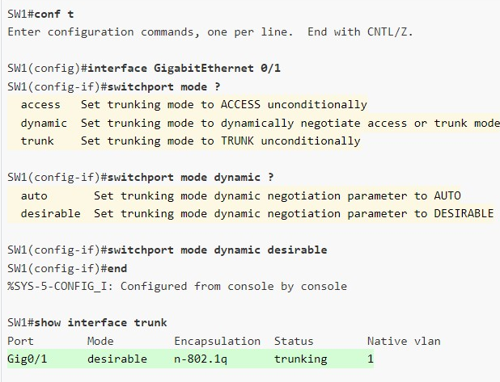

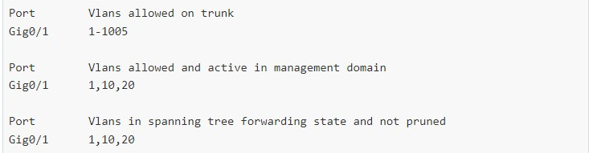

You can see from the output of **show interface trunk** command that a trunk link formed, even though we haven't configured anything on the other side of the link on switch 2. That is the function of the dynamic trunking protocol. Let's check what the status of the link is according to switch 2.

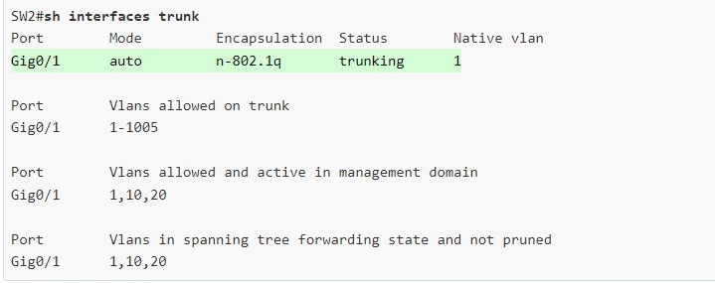

.

## Summary

* VLANs are **locally significant** and are stored in siwtch's local VLAN database.
* Trunk links **tag**frames with VLAN identification.
* IEEE 802.1Q is the **standard trunking mechanism** on Cisco switches. The old method called ISL has been deprecated and is not used anymore.
* Dymanimc Trunking Protocol (DTP) can **negotiate trunk links**.
* To form a trunk link between two switches, both have to be configured to allow trunking on each end of the link.

1. True or false? DTP is an open standard IEEE protocol that specifies auto negotiation of switch trunk links.



true



False

***ANS: The correct answer is False. DTP is a Cisco proprietary protocol for switchport trunk auto negotiation.***

2. What is the default switchport mode for Cisco Catalyst switches?



access



trunk



dynamic auto



dynamic desirable

**ANS: The default switchport mode for Cisco Catalyst switches is dynamic auto.**

3. True or false? Two switchports on a link both configured as dynamic auto will successfully negotiate a trunk.



True



False

***ANS: The correct answer is False. A switchport configured as dynamic auto will only form a trunk with another interface configured as either trunk or dynamic desirable***

4. Which two DTP modes will form a trunk with an interface that is configured as dynamic auto? (Choose two.)



access



trunk



dynamic auto



dynamic desirable

**ANS: A switchport configured as dynamic auto will only form a trunk with another interface configured as either trunk or dynamic desirable.**

3.6.1

Packet Tracer - Implement VLANs and Trunking(pending)

In this Packet Tracer activity, you will perform the following:

* Configure VLANs
* Assign Ports to VLANs
* Configure Static Trunking
* Configure Dynamic Trunking

3.6.2

## Lab - Implement VLANs and Trunking(pending)

In this lab, you will perform the following:

* Build the Network and Configure Basic Device Settings
* Create VLANs and Assign Switch Ports
* Configure an 802.1Q Trunk between the Switches

3.6.3

What did I learn in this module?

**Overview of VLANs**

Virtual LANs (VLANs) are a group of devices that can communicate as if each device was attached to the same cable.

VLANs are based on logical instead of physical connections. Administrators use VLANs to segment networks based on factors such as function, team, or application

. Each VLAN is considered a separate logical network. Any switch port can belong to a VLAN. A VLAN creates a logical broadcast domain that can span multiple physical LAN segments.

VLANs improve network performance by separating large broadcast domains into smaller ones. Each VLAN in a switched network corresponds to an IP network; therefore, VLAN design must use a hierarchical network-addressing scheme

. Types of VLANs include the

* **default VLAN,**
* **data VLANs**
* **native VLAN,**
* **Management VLANs.**
* **Voice VLANs.**

**VLANs in a Multi-Switched Environment**

A VLAN trunk does not belong to a specific VLAN.

It is a conduit for multiple VLANs between switches and routers.

***A VLAN trunk*** is a point-to-point link between two network devices that carries more than one VLAN.

A VLAN trunk extends VLANs across an entire network. When VLANs are implemented on a switch, the transmission of unicast, multicast, and broadcast traffic from a host in a particular VLAN are restricted to the devices that are in that VLAN.

VLAN tag fields include the type, user priority, CFI and VID. Some devices add a VLAN tag to native VLAN traffic. If an 802.1Q trunk port receives a tagged frame with the VID that is the same as the native VLAN, it drops the frame.

A separate voice VLAN is required to support VoIP. QoS and security policies can be applied to voice traffic. Voice VLAN traffic must be tagged with an appropriate Layer 2 CoS priority value.

**VLAN Configuration**

Different Cisco Catalyst switches support various numbers of VLANs including normal range VLANs and extended range VLANs.

When configuring normal range VLANs, the configuration details are stored in flash memory on the switch in a file called ***vlan.dat***.

Although it is not required, it is good practice to save running configuration changes to the startup configuration.

After creating a VLAN, the next step is to assign ports to the VLAN. There are several commands for defining a port to be an access port and assigning it to a VLAN. VLANs are configured on the switch port and not on the end device.

An access port can belong to only one data VLAN at a time. However, a port can also be associated to a voice VLAN.

For example, a port connected to an IP phone and an end device would be associated with two VLANs: one for voice and one for data.

After a VLAN is configured, VLAN configurations can be validated using Cisco IOS **show** commands. If the switch access port has been incorrectly assigned to a VLAN, then simply re-enter the **switchport access** **vlan** *vlan-id* interface configuration command with the correct VLAN ID. The **no vlan** *vlan-id* global configuration mode command is used to remove a VLAN from the switch vlan.dat file.

**VLAN Trunks**

A VLAN trunk is an OSI Layer 2 link between two switches that carries traffic for all VLANs. There are several commands to configure the interconnecting ports. To verify VLAN trunk configuration use the **show interfaces** *interface-ID* **switchport** command. Use the **no switchport trunk allowed vlan** and the **no switchport trunk native vlan** commands to remove the allowed VLANs and reset the native VLAN of the trunk.

**Dynamic Trunking Protocol**

An interface can be set to trunking or nontrunking, or to negotiate trunking with the neighbor interface.

Trunk negotiation is managed by the ***Dynamic Trunking Protocol (DTP),*** which operates on a point-to-point basis only, between network devices.

DTP is a Cisco proprietary protocol that manages trunk negotiation only if the port on the neighbor switch is configured in a trunk mode that supports DTP.

To enable trunking from a Cisco switch to a device that does not support DTP, use the **switchport mode trunk** and **switchport nonegotiate** interface configuration mode commands.

The **switchport mode** command has additional options for negotiating the interface mode including access, dynamic auto, dynamic desirable, and trunk. To verify the current DTP mode, issue the **show dtp interface** command.

3.6.4

## Module Quiz - VLANs

Top of Form

1. What happens to a port that is associated with VLAN 10 when the administrator deletes VLAN 10 from the switch?

Topic 3.3.0 - If the VLAN that is associated with a port is deleted, the port becomes inactive and cannot communicate with the network any more. To verify that a port is in an inactive state, use the **show interfaces switchport** command.



The port goes back to the default VLAN.



The port automatically associates itself with the native VLAN.



The port creates the VLAN again.



The port becomes inactive.

1. In which memory location are the VLAN configurations of normal range VLANs stored on a Catalyst switch?

Topic 3.3.0 - When a normal range VLAN is created the configuration information of the VLAN is stored in flash in the vlan.dat file.



flash



ROM



NVRAM



RAM

1. An administrator is investigating a failure on a trunk link between a Cisco switch and a switch from another vendor. After a few **show** commands, the administrator notices that the switches are not negotiating a trunk. What is a probable cause for this issue?

Topic 3.5.0 - DTP is a Cisco proprietary protocol. Non-Cisco switches do not support DTP.



Both switches are in nonegotiate mode.



Switches from other vendors do not support DTP.



DTP frames are flooding the entire network.



Both switches are in trunk mode.

1. What is the purpose of the vlan.dat file on a switch?

Topic 3.3.0 - The VLAN database (vlan.dat) contains information about normal range VLANs such as the VLAN number, name, and VTP mode.



It holds the VLAN database.



It holds the running configuration.



It holds the operating system.



It holds the saved configuration.

1. What is the purpose of setting the native VLAN separate from data VLANs?

Topic 3.1.0 - When a Cisco switch trunk port receives untagged frames (unusual in well-designed networks), it forwards these frames to the native VLAN. When the native VLAN is moved away from data VLANs, those untagged frames will not compete for bandwidth in the data VLANs. The native VLAN is not designed for carrying management traffic, but rather it is for backward compatibility with legacy LAN scenarios.



The native VLAN is for carrying VLAN management traffic only.



A separate VLAN should be used to carry uncommon untagged frames to avoid bandwidth contention on data VLANs.



The security of management frames that are carried in the native VLAN can be enhanced.



The native VLAN is for routers and switches to exchange their management information, so it should be different from data VLANs.

1. When a Cisco switch receives untagged frames on a 802.1Q trunk port, which VLAN ID is the traffic switched to by default?

Topic 3.2.0 - A native VLAN is used to forward untagged frames that are received on a Cisco switch 802.1Q trunk port. Untagged frames that are received on a trunk port are not forwarded to any other VLAN except the native VLAN.



management VLAN ID



unused VLAN ID



native VLAN ID



data VLAN ID

1. A network administrator is determining the best placement of VLAN trunk links. Which two types of point-to-point connections utilize VLAN trunking?​ (Choose two.)

Topic 3.2.0 - VLAN trunk links are used to allow all VLAN traffic to propagate between devices such as the link between a switch and a server that has an 802.1Q-capable NIC. Switches can also utilize trunk links to routers, servers, and to other switches.



between a switch and a client PC



between two switches that utilize multiple VLANs



between two switches that share a common VLAN



between a switch and a server that has an 802.1Q NIC



between a switch and a network printer

1. What are three primary benefits of using VLANs? (Choose three.)

Topic 3.1.0 - Security, cost reduction, and improved IT staff efficiency are all benefits of using VLANs, along with higher performance, broadcast storm mitigation, and simpler project and application management. End users are not usually aware of VLANs, and VLANs do require configuration. Because VLANs are assigned to access ports, they do not reduce the number of trunk links.



end user satisfaction



cost reduction



a reduction in the number of trunk links



security

1. On a Cisco switch, where is extended range VLAN information stored?

Topic 3.3.0 - Extended range VLANs, 1006 through 4094, are not written to the vlan.dat file but are saved in the running configuration file.



running configuration file



flash



startup configuration file



NVRAM

1. In which location are the normal range VLANs stored on a Cisco switch by default?

Topic 3.1.0 - Normal range VLANs are stored in a file called vlan.dat and located in the flash memory.



RAM



flash memory



startup-config



running-config

1. Which distinct type of VLAN is used by an administrator to access and configure a switch?

Topic 3.1.0 - A management VLAN is used to remotely access and configure a switch. Data VLANs are used to separate a network into groups of users or devices. The default VLAN is the initial VLAN all switch ports are placed in when loading the default configuration on a switch. The 802.1Q trunk port places untagged traffic on the native VLAN.



native VLAN



default VLAN



data VLAN



management VLAN

1. For what reason would a network administrator use the **show interfaces trunk** command on a switch?

Topic 3.3.0 - The **show interfaces trunk** command displays the ports that are trunk ports, the trunking mode, the encapsulation type, the trunk status, the native VLAN, and the allowed VLANs on the link.



to display an IP address for any existing VLAN



to view the native VLAN



to verify port association with a particular VLAN



to examine DTP negotiation as it occurs

1. Where is the vlan.dat file stored on a switch?

Topic 3.3.0 - Normal range VLAN configurations are stored within a VLAN database file, called vlan.dat, which is located in the flash memory of the switch.



in RAM



on the externally attached storage media or internal hard drive



in NVRAM



in flash memory

1. If an organization is changing to include Cisco IP phones in its network, what design feature must be considered to ensure voice quality?

Topic 3.1.0 - A PC commonly connects to an IP phone and the IP phone, in turn, connects to a switch. The phone does not require a separate port. Because voice traffic cannot tolerate much packet delay, it needs to be in a separate VLAN.  The voice VLAN can be configured to provide quality of service (QoS), which will ensure that the voice traffic has a higher priority than data traffic.



Voice traffic needs to be tagged with the native VLAN.



Voice traffic and data traffic require separate trunk links between switches.



A separate VLAN is needed for voice traffic.



Additional switch ports that are dedicated to Cisco IP phones are required.

1. A Cisco switch currently allows traffic tagged with VLANs 10 and 20 across trunk port Fa0/5. What is the effect of issuing a **switchport trunk allowed vlan 30** command on Fa0/5?

Topic 3.4.0 - The **switchport trunk allowed vlan 30** command allows traffic that is tagged with VLAN 30 across the trunk port. Any VLAN that is not specified in this command will not be allowed on this trunk port.



It allows a native VLAN of 30 to be implemented on Fa0/5.



It allows only VLAN 30 on Fa0/5.



It allows VLANs 1 to 30 on Fa0/5.



It allows VLANs 10, 20, and 30 on Fa0/5.